5E Lesson Planning Template
Grade/ Grade Band: 7th grade / Life Science | Topic: Cells | Cycle # _____ in a series of _____ Cycles
Brief Lesson Description: Students will examine cells under a microscope to differentiate plant and animal cells
Current TN Science standards:
Course Level Expectations
GLE 0707.1.1 Make observations and describe the structure and function of organelles found in plant and animal cells.

Checks for understanding:
0707.1.1 Examine and describe plant and animal cells using compound microscopes.
0707.1.1 Examine and describe plant and animal cells using compound microscopes.
0707.1.4 Build a 3-D model of a cell.

State performance indicators:
SPI 0707.1.1 Identify and describe the function of the major plant and animal cell organelles.

New TN Academic Standards for Science:
7.LS1: From Molecules to Organisms: Structures and Processes
1) Develop and construct models that identify and explain the structure and function of major cell organelles as they contribute to the life activities of the cell and organism.

3) Evaluate evidence that cells have structural similarities and differences in organisms across kingdoms.

Science & Engineering Practices: | Crosscutting Concepts:
Narrative / Background Information
Prior Student Knowledge:
Students might have some familiarity with cells from previous life science classes. They should know the difference between the plant and animal kingdoms.
Possible Preconceptions/Misconceptions:
Students may not realize there are living things too small for us to see with our own eyes. Some students also may not realize that living things are made up of smaller parts; they may just look at a living organism as one unit.
Students often confuse “cells” and “atoms.”
LESSON PLAN – 5-E Model
ENGAGE: Opening Activity – Access Prior Learning / Stimulate Interest / Generate Questions:
Begin by asking students to brainstorm everything they already know about cells. Give students 1-2 minutes to write quietly, then share and record on the board in a K-W-L chart.
Next, ask students what questions they have about cells. Again, give them a few minutes to write quietly, hen share and record in the K-W-L chart.
Tell students we’ll be exploring cells today and will try to answer as many questions as possible!

EXPLORE: Lesson Description – Materials Needed / Probing or Clarifying Questions:
**From Science Scope article
Students should work in small groups depending on how many microscopes are available. Each student should get a chance to prepare and look at their own slides, if possible. Tell students we are going to try to figure out if there is a difference between plant and animal cells by looking at them very closely under a microscope.
Begin by having students observe the onion cell through a microscope to identify the parts of a plant cell. To prepare a slide, students should peel off the outer layers of an onion until they reach the first shiny level. Next, they must carefully peel off a paper-thin layer and place it on a slide. Having the students use their fingernails to remove the skin and then use tweezers to place the skin on the slide has proven to be successful for my students. Finally, they need to add a small amount of dark food coloring (such as blue or green) for stain and add a cover slip.
Once students have prepared their slides, they can view them through a microscope. Students should work in groups to help each other identify the organelles, but each student must create their own sketch of the cell based on their observations. Each group can share their findings with the class by having one member sketch and label the group’s cell on the board or a piece of poster paper. Students are then free to circulate around the room to view the other cells and identify any organelles that weren’t visible on their slide.
To view an animal cell, students gently scrape the inside of their cheeks with the blunt end of a toothpick and then transfer the scrapings to a small drop of water on a microscope slide. (Gloves should be worn during this procedure and all used materials should be disposed of or cleaned properly. Avoid having any students handle the prepared slides except for the donor of the cheek cells.) Again, dark food coloring is added as a dye and a cover slip is placed on top of the slide. Students follow the same procedure used with the onion cell to identify the organelles, sketch their findings, and share their work with the class.
Once students have viewed their own slides, they can also look at samples of prepared slides to refine their sketches. Provide groups with a few plant cell and a few animal cell slides and have them look for similarities and differences across the groups.

EXPLAIN: Concepts Explained and Vocabulary Defined:

Once groups have looked at their slides, collect all the posters of each type of cell and use them to create a

Project a picture of a cheek cell and an onion cell on the board and ask groups to share what they noticed in terms of similarities and differences.
Groups should point out that both have a spot in the middle – Label this the nucleus and tell them that all cells have a nucleus that controls the action of the cell.
Groups should point out that the onion cells are more structured that the cheek cells and are a more uniform shape. Point out and label the cell wall on the onion cells Ask students what they think the function of the cell wall is? To protect the cell, give it shape, make it stronger
Explain that animal cells have a cell membrane that protect it, but it’s not as rigid as a cell wall. Point out the cell membranes on the cheek cell.
Students might also point out that both cells look like they are full of something – explain that cells have cytoplasm, which is like a jelly inside the cell membrane/cell wall that fills up the cell.

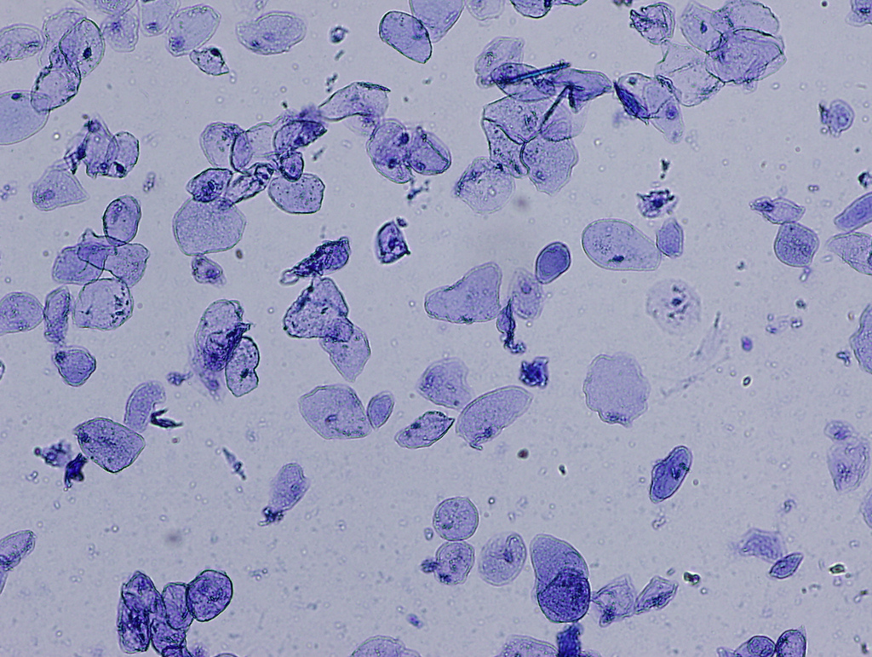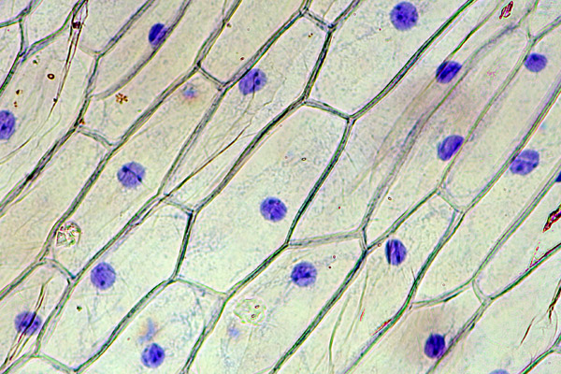

If you have really good microscopes and/or slides, students might be able to see other small things in the cells. Tell them that these are organelles and each one has a specific function in the cell. Because cells are SO tiny, it is hard to see all the organelles, so scientists use models to represent them. Show a blank cell model on the board.

Ask students: What other things does a cell need to be able to do if it is living?
- Digest food – lysosomes
- Make protein - ribosomes
- Get energy- mitochondria
- Store things like food and waste - vacuoles
- Move things around – endoplasmic reticulum
- Store proteins before they are removed from cell – golgi apparatus
**You may do fewer/more organelles in your model

As students come up different functions of the cell, ask them to predict which organelle structure (in the unlabeled diagram) would best help serve that function and label them on the cell. Write in names of the organelles as you go.

You can also show an animal cell model and ask students what additional functions plant cells need. The main one is photosynthesis – point out the chloroplasts where photosynthesis happens.

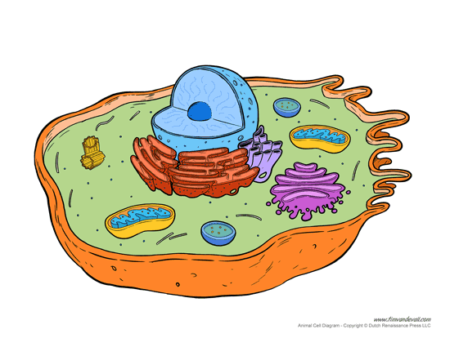
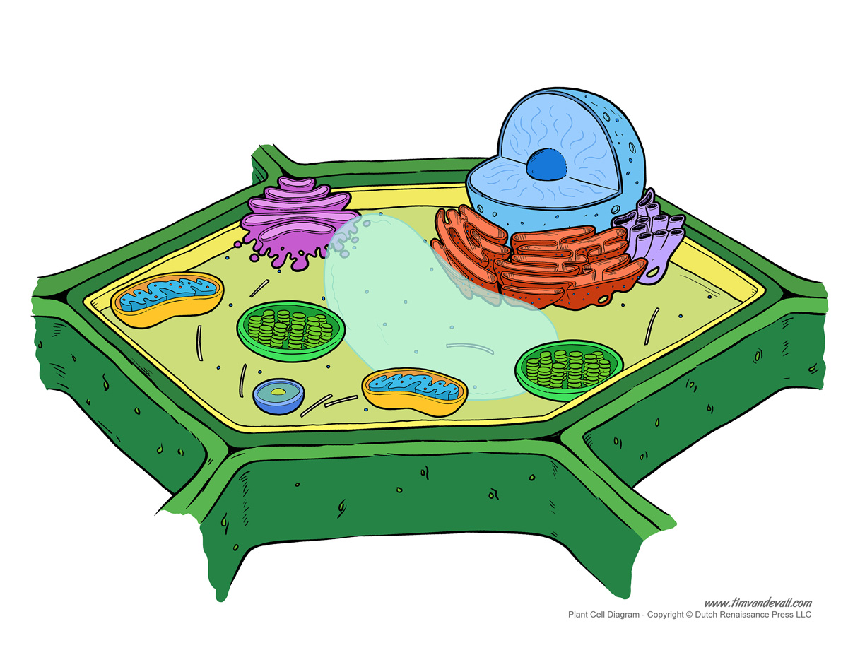
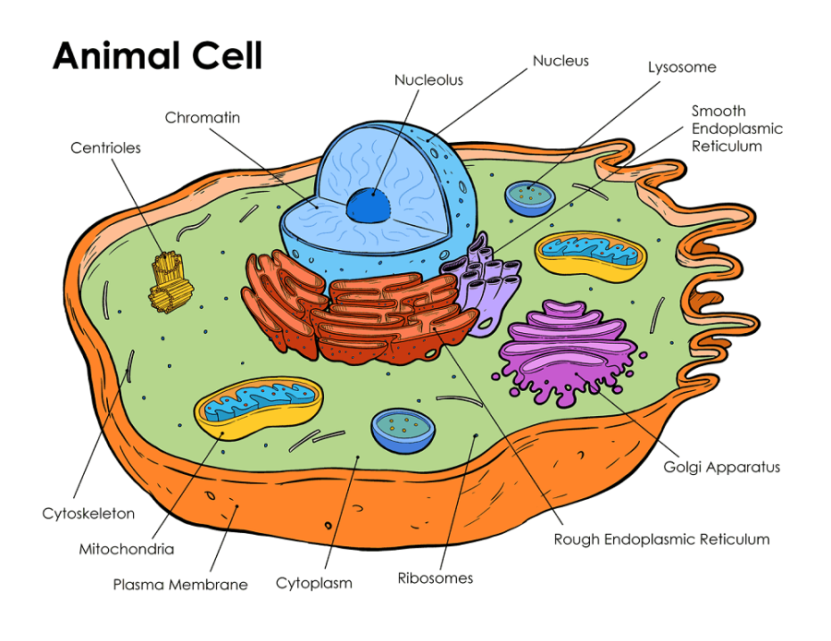

Vocabulary:
Nucleus
Cell Membrane
Cell Wall
Cytoplasm
Organelles

ELABORATE: Applications and Extensions:

Next, have students create an analogy of a cell. You can have them do this in multiple ways – a story, a poster, a presentation. I like a poster because you can leave them displayed in the classroom.

If students need help with the analogy, offer a simple example to get them started: If a cell is a school, then the nucleus would be the front office.
Other examples if students need a push: A city, a sports team, a house, a restaurant

EVALUATE:
You should evaluate the analogy based on the whether the student included each of the organelles, how well the function of the organelle is reflected in the analogy, and how creative the analogy is.

At the end of the learning cycle, return to the K-W-L chart and ask students to answer as many of the questions as possible. Depending on the questions, you may want to mark the ones that can definitely be answered for students.
Have students share their answers for the questions.

