5E Lesson Plan
Grade/ Grade Band: 7th Grade | Topic: Heredity | Cycle # _____ in a series of _____ Cycles
Brief Lesson Description: Students learn how traits are passed from parents to offspring

Current TN Science standards:
Course Level Expectations
GLE 0707.4.3 Explain the relationship among genes, chromosomes, and inherited traits.
GLE 0707.4.4 Predict the probable appearance of offspring based on the genetic characteristics of the parents.

Checks for understanding:
90707.4.4 Investigate the relationship among DNA, genes, and chromosomes.
90707.4.5 Explain the differences between dominant and recessive traits.
90707.4.6 Use a Punnett square to predict the genotypes of offspring resulting from a monohybrid cross.
90707.4.7 Draw a phenotypically accurate picture of an individual whose traits are modeled by the role of a die.

State performance indicators:
SPI 0707.4.3 Describe the relationship among genes, chromosomes, and inherited traits.
SPI 0707.4.4 Interpret a Punnett square to predict possible genetic combinations passed from parents to offspring during sexual reproduction.
New TN Academic Standards for Science:
7.LS3: Heredity: Inheritance and Variation of Traits
1) Hypothesize that the impact of structural changes to genes (i.e., mutations) located on chromosomes may result in harmful, beneficial, or neutral effects to the structure and function of the organism.
2) Distinguish between mitosis and meiosis and compare the resulting daughter cells.
3) Predict the probability of individual dominant and recessive alleles to be transmitted from each parent to offspring during sexual reproduction and represent the phenotypic and genotypic patterns using ratios.

Science & Engineering Practices: | Crosscutting Concepts:
Narrative / Background Information
Prior Student Knowledge:
Students should have a general understanding of sexual reproduction
Possible Preconceptions/Misconceptions:
Students may think that offspring always look just like their parents, or just like each other
LESSON PLAN – 5-E Model
ENGAGE: Opening Activity – Access Prior Learning / Stimulate Interest / Generate Questions:

To engage students, ask them to write down the answer to the following question:
If the two dogs pictured below had puppies, what would the puppies look like?

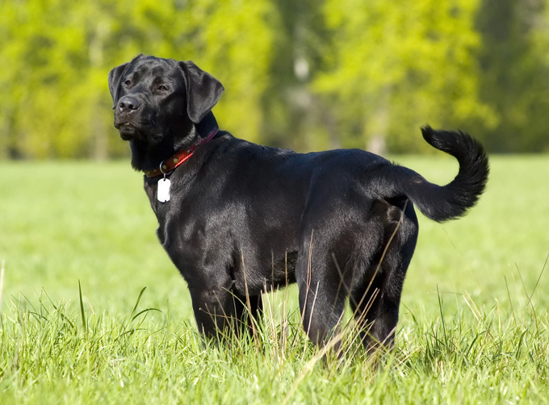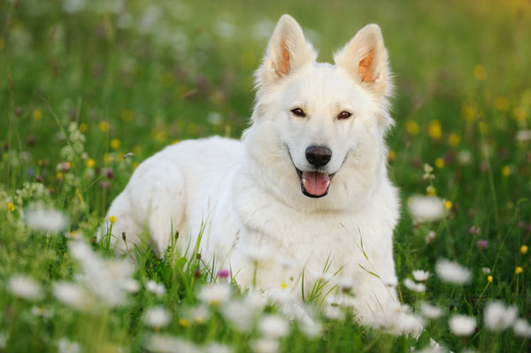

After giving students a few minutes to record their thoughts, ask for volunteers to share their answers.
Record common answers on the board. Some answers might include: Half the puppies will be white, half will be black; the puppies will have black and white spots; the puppies will be gray

Push students to think about other characteristics – how large will the puppies be? What will their ears be like? How about their fur – will it be short or long?

Record students thoughts.

EXPLORE: Lesson Description – Materials Needed / Probing or Clarifying Questions:

Modeling Mendel Box Activity – See article attached for full details

In this activity, the teacher draws blue and white cards from a box to model how traits are passed down from parents to offspring. Using blue and white cards, the teacher draws combinations of cards to represent different combinations of offspring.

The first round represents crossing two dominant alleles (BB and BB): two blue cards are put in and four blue cards are drawn out.

The next round represents crossing a dominant (BB) and recessive (bb) allele. A blue card and white card are put in, and four blue cards are taken out.

Students should record the results of each round.

After two rounds of drawing cards, the students predict what will happen if they cross the results of each round (BB and Bb). Students record their predictions. Have students share their predictions and explain them before putting in one card from the first round and one card from the second round and drawing four cards – which are all blue (Bb).

Have students record the results and then ask them to predict what will happen if you use two cards from cross two? Have students share and explain their predictions and then put the two cards in. This time, draw three blue cards and one white card.

Give students time to discuss in their group what they think the explanation is. Ask the students, “Does it matter which blue cards we cross? Are all the blue cards the same?” Have student groups suggest cards to cross and produce the results.

EXPLAIN: Concepts Explained and Vocabulary Defined:

Guide the students through a discussion of what they think is the difference in the cards (see the discussion on p. 52-53 of Modeling Mendel), and discuss how to label the cards. Students should understand that there are “strong” and “weak” blues and that two strong blues make another blue, but two weak blues make a white card. Introduce the terms dominant and recessive and relate them to the blue and white cards.

Depending on the level of your students and how detailed you want to be, you can also introduce the additional vocabulary below, relating it to the activity.

Next, introduce students to Punnett Squares by drawing a 2x2 grid on the board. Ask them how they can use it to make predictions about the card crosses? Let students make suggestions, guiding them to putting one parent on each side and the offspring in the middle.

Vocabulary:
Punnett Square
Allele
Dominant
Recessive
Gene
Trait
Incomplete dominance
Purebred
Hybrid
Genotypes
Phenotypes

ELABORATE: Applications and Extensions:

The Alien Lab Activity – See article attached for full details

Now that students have a basic understanding of how parents pass down ONE trait to their offspring, they are going to apply that understanding to passing down multiple traits in an alien population.
First, working with a partner, students each flip a coin and record both their own and their partner’s results. They repeat this 12 times, recording each result.

Next, as a class brainstorm a list of physical characteristics of an alien and record that list on the board, and what the dominant and recessive traits would look like.

Finally, using their list of coin flips and the trait key, students sketch their aliens!

Extension: After students have created their own alien, have them mate with someone else’s alien and draw the offspring! See p. 25-26 in the article for a full description.

EVALUATE:
Have students revisit the question from the engage section and provide a written response, using what they’ve learned.

